**TDD using JUnit5 and Mockito**

**Exercise 1: Setting Up Junit**

**pom.xml(junitsetup):**

<project xmlns="http://maven.apache.org/POM/4.0.0"

xmlns:xsi="http://www.w3.org/2001/XMLSchema-instance"

xsi:schemaLocation="http://maven.apache.org/POM/4.0.0

http://maven.apache.org/xsd/maven-4.0.0.xsd">

<modelVersion>4.0.0</modelVersion>

<groupId>com.example</groupId>

<artifactId>junitsetup</artifactId>

<version>1.0-SNAPSHOT</version>

<dependencies>

<dependency>

<groupId>junit</groupId>

<artifactId>junit</artifactId>

<version>4.13.2</version>

<scope>test</scope>

</dependency>

<dependency>

<groupId>org.testng</groupId>

<artifactId>testng</artifactId>

<version>RELEASE</version>

<scope>test</scope>

</dependency>

</dependencies>

</project>

**Calculator .java**

import org.testng.annotations.Test;

import static org.junit.Assert.assertEquals;

public class CalculatorTest {

@Test

public void testAddition() {

int result = 2 + 3;

assertEquals(5, result);

}

}

**Output:**

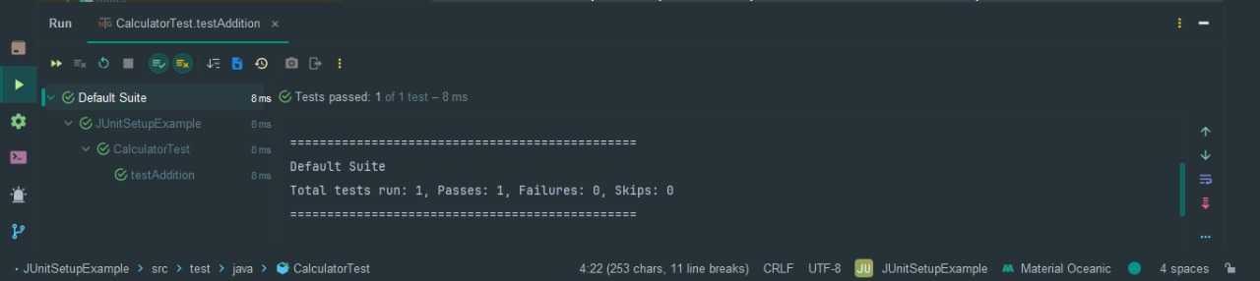

**Exercise 3: Assertions in Junit**

**AssertionsTest.java**

import org.junit.Test;

import static org.junit.Assert.*;

public class AssertionsTest {

@Test

public void testAssertions() {

assertEquals(5, 2 + 3);

assertTrue(5 > 3);

assertFalse(5 < 3);

assertNull(null);

assertNotNull(new Object());

}

}

**Output:**

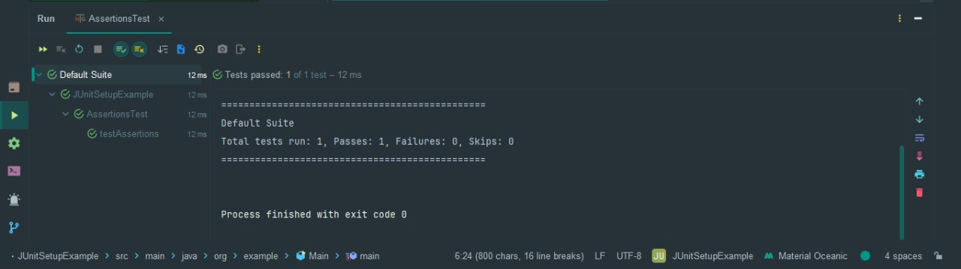

**Exercise 4: Arrange-Act-Assert (AAA) Pattern, Test Fixtures, Setup and Teardown methods in Junit**

**Class name: CalculatorTest.java**

import org.junit.Before;

import org.junit.After;

import org.junit.Test;

import static org.junit.Assert.*;

public class CalculatorTest {

private Calculator calculator;

// Setup: runs before each test

@Before

public void setUp() {

calculator = new Calculator();

System.out.println("Setup: Calculator instance created");

}

// Teardown: runs after each test

@After

public void tearDown() {

calculator = null;

System.out.println("Teardown: Calculator instance cleared");

}

@Test

public void testAddition() {

// Arrange

int a = 2;

int b = 3;

// Act

int result = calculator.add(a, b);

// Assert

assertEquals(5, result);

}

@Test

public void testSubtraction() {

// Arrange

int a = 5;

int b = 3;

// Act

int result = calculator.subtract(a, b);

// Assert

assertEquals(2, result);

}

}

**Output:**

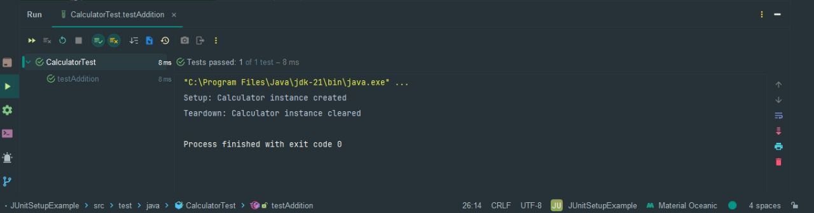

**Class Name: Calculator.java**

public class Calculator {

public int add(int a, int b) {

return a + b;

}

public int subtract(int a, int b) {

return a - b;

}

}

**Output:**

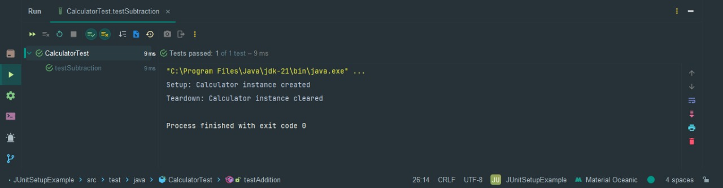

**Mockito**

**Exercise 1: Mocking and Stubbing**

**ExternalApi.java**

package org.example;  
  
public interface ExternalApi {  
 String getData();  
}

**MyService.java**

package org.example;  
  
public class MyService {  
 private final ExternalApi api;  
  
 // Constructor injection  
 public MyService (ExternalApi api) {  
 this.api = api;  
 }  
  
 public String fetchData () {  
 return api.getData (); // Calls external API  
 }  
}

**MyServiceTest.java**

import static org.mockito.Mockito.*;  
import static org.junit.jupiter.api.Assertions.*;  
  
import org.example.ExternalApi;  
import org.example.MyService;  
import org.junit.jupiter.api.Test;  
import org.mockito.Mockito;  
  
public class MyServiceTest {  
  
 @Test  
 public void testExternalApi() {  
 // Step 1: Create mock object  
 ExternalApi mockApi = Mockito.mock(ExternalApi.class);  
  
 // Step 2: Stub the getData() method  
 when(mockApi.getData()).thenReturn("Mock Data");  
  
 // Step 3: Inject mock into service  
 MyService service = new MyService(mockApi);  
  
 // Step 4: Call the method and assert result  
 String result = service.fetchData();  
 assertEquals("Mock Data", result); // Assert result matches stubbed value  
 }  
}

**OUTPUT :**

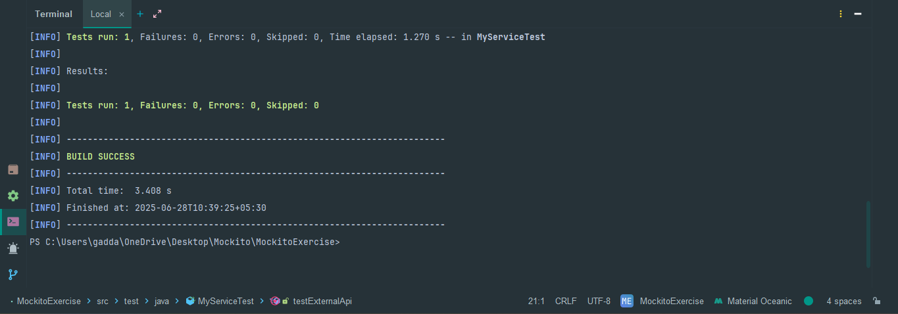

**Exercise 2: Verifying Interactions**

**ExternalApi.java**

package org.example;  
  
public interface ExternalApi {  
 String getData();  
}

**MyService.java**

package org.example;  
  
public class MyService {  
 private ExternalApi api;  
  
 public MyService(ExternalApi api) {  
 this.api = api;  
 }  
  
 public String fetchData() {  
 return api.getData(); // This is the call we want to verify  
 }  
}

**MyServiceTest.java**

import static org.mockito.Mockito.*;  
import static org.junit.jupiter.api.Assertions.*;  
  
import org.example.ExternalApi;  
import org.example.MyService;  
import org.junit.jupiter.api.Test;  
import org.mockito.Mockito;  
  
public class MyServiceTest {  
  
 @Test  
 public void testExternalApi() {  
 // Step 1: Create mock object  
 ExternalApi mockApi = Mockito.mock(ExternalApi.class);  
  
 // Step 2: Stub the getData() method  
 when(mockApi.getData()).thenReturn("Mock Data");  
  
 // Step 3: Inject mock into service  
 MyService service = new MyService(mockApi);  
  
 // Step 4: Call the method and assert result  
 String result = service.fetchData();  
 assertEquals("Mock Data", result); // Assert result matches stubbed value  
 }  
}

**OUTPUT :**

